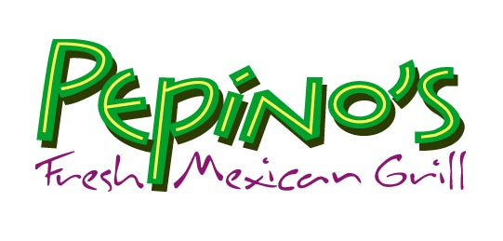

Richmond School Fundraiser
Come Support Your School
It’s Easy and Delicious

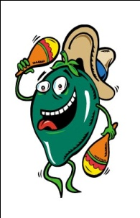

Join us any time of the day on Tuesday, May 18th, and 20% of your purchase dollars will go to
Richmond School

Make sure you bring this flyer with you and give it to the cashier before you order!

This event will be held at both Pepino’s locations:

914 NW 23rd
tel: 503-227-8271
or
3832 SE Hawthorne Blvd.
tel: 503-236-5000

** Tuesday’s free children’s meals will not be available for this day**

